A
REPORT
Of
MINI PROJECT OR INTERNSHIP ASSESSMENT
At
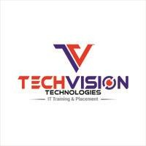
“Techvision Technologies”
On
“Full Stack Development”
Submitted
In the partial fulfillment of
Bachelor of Technology
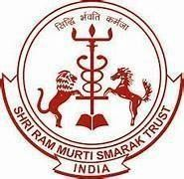
Department of Computer Science and Engineering

Shri Ram Murti Smarak College of Engineering and Technology
Bareilly
Session: 2025-2026

Submitted by: Submitted to:
Name: Parkhi Dr. Juhi Chaudhary
Roll No.: 2200140100074 Assistant Professor (CSE Dept.)

